SIMATS ENGINEERING
ASSESSMENT TOOL 1

COURSE NAME: INTERNET PROGRAMMING
COURSE CODE: CSA43

COURSE OUTCOME COVERED

CO-1 : Develop well-structured, standards-compliant web pages using HTML/XHTML and XML, and apply Internet protocols and HTTP communication mechanisms for web content delivery. (L2)

Assessment Tool : Application-Based Questions

Weightage: 40%

QUESTIONS: Total Marks: 30

1: Online Symposium Portal
A college is developing an online symposium registration portal. The following HTML structure and HTTP interaction is observed:
<form action="/register" method="POST">
<input type="text" name="name">
<input type="email" name="email">
<button>Submit</button>
</form>
When a student submits the form, the browser sends an HTTP request to the server, and the server responds accordingly.
Questions:
- Identify appropriate HTML5 semantic elements missing in the structure.
<header> – For the portal heading.
<main> – For the main content.
<section> – For the registration section.
<footer> – For footer information.
<label> – To describe form input fields.

- Modify the structure to make it standards-compliant.
<!DOCTYPE html>
<html lang="en">
<head>
<meta charset="UTF-8">
<meta name="viewport" content="width=device-width, initial-scale=1.0">
<title>Online Symposium Portal</title>
</head>
<body>

<header>
<h1>Online Symposium Portal</h1>
</header>

<main>
<section>
<h2>Registration Form</h2>

<form action="/register" method="POST">
<label for="name">Name:</label>
<input type="text" id="name" name="name" required>

<br><br>

<label for="email">Email:</label>
<input type="email" id="email" name="email" required>

<br><br>

<button type="submit">Submit</button>
</form>
</section>
</main>

<footer>
<p>Online Symposium Portal</p>
</footer>

</body>
</html>

- Interpret the HTTP request generated during form submission.
When the user clicks Submit, the browser sends a POST request containing the name and email to the /register endpoint on the server.

- Analyze the HTTP response cycle from server to browser.
The server receives the request, processes the registration data, and sends an HTTP response. The browser then displays the response to the user.

- Suggest improvements for usability and accessibility.
Use <label> for each input field.
Use required for mandatory fields.
Use type="email" for email validation.

Output:
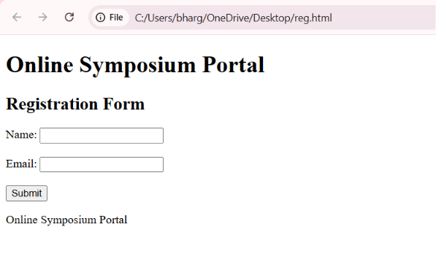

2: Cross-Browser Compatibility Issue
A company website shows inconsistent layout across browsers. The following HTML snippet is used:
<html>
<head>
<title>Company</title>
</head>
<body>
<div>
<h1>Welcome
<p>About us
</div>
</body>
</html>
Questions:
- Identify improper nesting and missing closing tags.
<h1>Welcome</h1>
<p>About us</p>

- Analyze how different browsers may interpret this structure.
Chrome, safari and brave.

- Identify missing semantic elements (e.g., header, section).

<header> – Used for the heading of the webpage.
<main> – Used for the main content.
<section> – Used to group related content.

- Provide a corrected W3C-compliant HTML structure.

<!DOCTYPE html>
<html lang="en">
<head>
<meta charset="UTF-8">
<meta name="viewport" content="width=device-width, initial-scale=1.0">
<title>Company</title>
</head>
<body>

<header>
<h1>Welcome</h1>
</header>

<main>
<section>
<p>About us</p>
</section>
</main>

</body>
</html>

- Suggest techniques to ensure cross-browser compatibility.
Use valid HTML5 code and properly close all tags.
Follow W3C web standards.

Output:
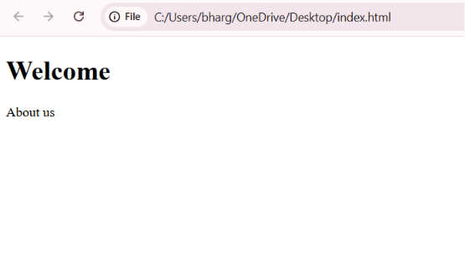

3: Form Submission Failure
A web application fails to send form data to the server. The following configuration is observed:
<form action="/submit" method="GET">
<input type="text" name="username">
<input type="password" name="password">
<button type="button">Login</button>
</form>
Questions:
- Identify issues in the form configuration.
type="button" does not submit the form.
type="button" does not submit the form.

- Analyze why the HTTP request is not triggered.
The button uses type="button", so clicking it does not submit the form. It should be changed to type="submit".

- Interpret the role of GET method in this scenario.
The GET method sends form data through the URL

- Propose a corrected implementation.
<!DOCTYPE html>
<html lang="en">
<head>
<meta charset="UTF-8">
<meta name="viewport" content="width=device-width, initial-scale=1.0">
<title>Login Form</title>
</head>
<body>

<h2>Login Form</h2>

<form action="/submit" method="POST">
<label for="username">Username:</label>
<input type="text" id="username" name="username" required>

<br><br>

<label for="password">Password:</label>
<input type="password" id="password" name="password" required>

<br><br>

<button type="submit">Login</button>
</form>

</body>
</html>

- Suggest improvements for secure data transmission.
Use POST instead of GET.
Use HTTPS.

Output:
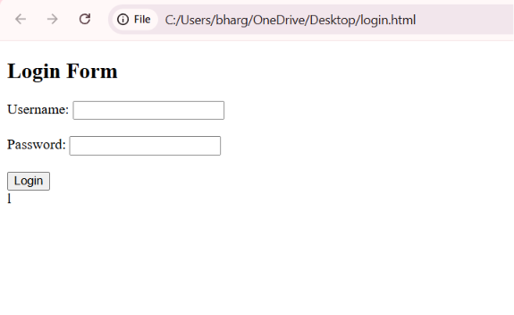

Code of Conduct:

I _Ch. Bhargav Ram (192425334)__ (Name / Reg No) certify that this submission is my original work and that I have adhered to the guidelines specified for this assessment.
I understand that any violation of academic integrity rules will result in disciplinary action.

Signature of the student:

RUBRICS FOR CALCULATION:

Criteria | Weightage | Level 4 – Exemplary | Level 3 – Proficient | Level 2 – Developing | Level 1 – Beginning
Understanding of Concepts | 25% | Demonstrates thorough, accurate understanding of concepts | Good understanding with minor gaps | Basic understanding with some misconceptions | Poor understanding; major misconceptions
Explanation | 25% | Detailed, well-explained answers with relevant examples | Clear explanation with adequate details | Limited explanation; lacks depth | Poor or unclear explanation
Application | 20% | Effectively applies concepts with strong analytical ability | Applies concepts with minor errors | Limited application with weak analysis | No application or incorrect analysis
Organization | 15% | Well-structured answers with logical flow and coherence | Organized with minor issues in flow | Basic structure, lacks clarity | Poor organization, incoherent answers
Accuracy | 10% | Completely accurate and covers all required points | Mostly accurate with minor omissions | Partially correct with missing points | Incorrect answers with major gaps
Clarity | 5% | Clear, neat, professional presentation | Understandable with minor issues | Limited clarity, readability issues | Poorly written, difficult to understand

